Task 1: Student Registration & Data Storage
Aim : To design and develop a web-based Student Registration System using HTML5 and CSS3 for the front-end interface and a MySQL database for storing student details, and to implement data retrieval using SQL queries.
Algorithm:
- Start the program.
- Display the student registration form.
- User enters details (Name, Email, DOB, Department, Phone).
- Submit the form using POST method.
- Connect to the MySQL database.
- Insert the entered data into the students table.
- Execute SELECT query to retrieve stored data.
- Display the student records on the screen.
- Stop the program.
Program :
index.html:
<!DOCTYPE html>
<html>
<head>
<title>Student Registration</title>
<style>
body {
font-family: Arial;
background-color: #f2f2f2;
}
.form-container {
width: 400px;
margin: 50px auto;
background: white;
padding: 20px;
border-radius: 10px;
} input, select {
width: 100%;
padding: 10px;
margin: 8px 0;
}
button {
background-color: green;
color: white;
padding: 10px;
border: none;
width: 100%;
}
</style>
</head>
<body>
<div class="form-container">
<h2>Student Registration</h2>
<form action="insert.php" method="POST">
<input type="text" name="name" placeholder="Name" required>
<input type="email" name="email" placeholder="Email" required>
<input type="date" name="dob" required>
<select name="department" required>
<option value="">Select Department</option>
<option>CSE</option>
<option>ECE</option>
<option>EEE</option>
<option>MECH</option>
</select>
<input type="text" name="phone" placeholder="Phone" required>

<button type="submit">Register</button>
</form>
</div>
</body>
</html>
db.php:
<?php
$conn = new mysqli("localhost", "root", "", "student_db");
if ($conn->connect_error) {
die("Connection failed: " . $conn->connect_error);
}
?>
insert.php:
<?php
include 'db.php';
$name = $_POST['name'];
$email = $_POST['email'];
$dob = $_POST['dob'];
$department = $_POST['department'];
$phone = $_POST['phone'];
$sql = "INSERT INTO students (name, email, dob, department, phone)
VALUES ('$name', '$email', '$dob', '$department', '$phone')";
if ($conn->query($sql) === TRUE) {
echo "<h3>Data Inserted Successfully!</h3>";
echo "<a href='view.php'>View Students</a>";
} else {
echo "Error: " . $conn->error;
}
$conn->close();
?>
view.php:
<?php
include 'db.php';
$sql = "SELECT * FROM students";
$result = $conn->query($sql);
echo "<h2>Student Records</h2>";
echo "<table border='1' cellpadding='10'>
<tr>
<th>ID</th>
<th>Name</th>
<th>Email</th>
<th>DOB</th>
<th>Department</th>
<th>Phone</th>
</tr>";
while ($row = $result->fetch_assoc()) {
echo "<tr>
<td>{$row['id']}</td>
<td>{$row['name']}</td>
<td>{$row['email']}</td>
<td>{$row['dob']}</td>
<td>{$row['department']}</td>
<td>{$row['phone']}</td>
</tr>";
}
echo "</table>";
$conn->close();
?>
SQL:
CREATE DATABASE student_db;
USE student_db;
CREATE TABLE students (
id INT AUTO_INCREMENT PRIMARY KEY,
name VARCHAR(100),
email VARCHAR(100),
dob DATE,
department VARCHAR(50),
phone VARCHAR(15)
);
OUTPUT:
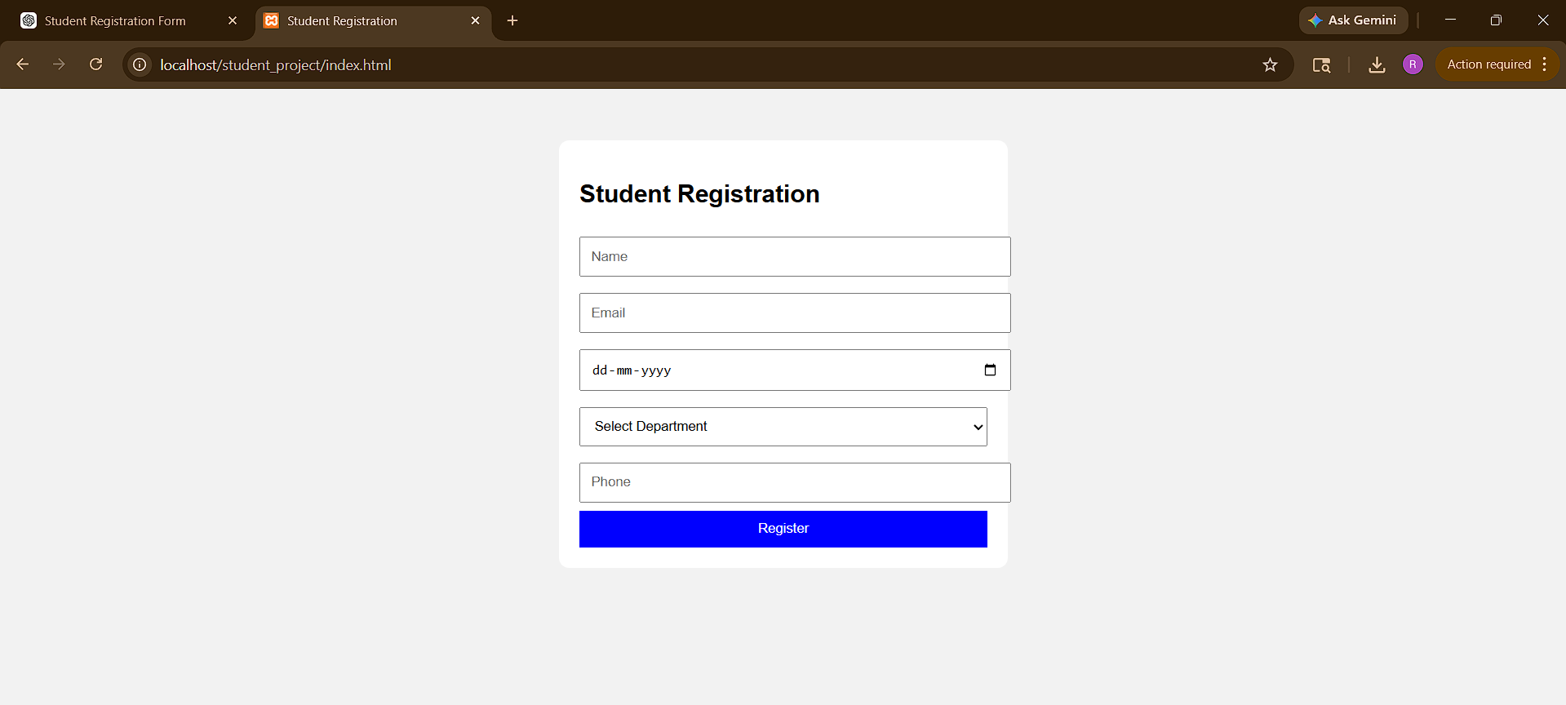
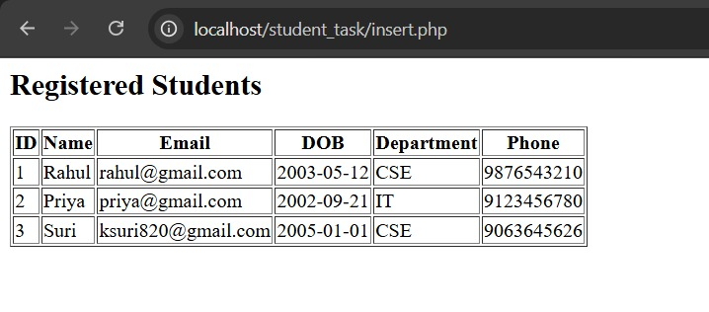
Result:Thus, the student registration form is executed successfully and output generated.

